Week 6
Task 1:
Program:
import java.io.*;
import java.math.*;
import java.security.*;
import java.text.*;
import java.util.*;
import java.util.concurrent.*;
import java.util.function.*;
import java.util.regex.*;
import java.util.stream.*;
import static java.util.stream.Collectors.joining;
import static java.util.stream.Collectors.toList;

class Result {

public static int stringSimilarity(String s) {
// Write your code here
int n = s.length();
int[] z = new int[n];
int left = 0, right = 0;
int sum = n;
for (int i = 1; i < n; i++) {
if (i <= right) {
z[i] = Math.min(right - i + 1, z[i - left]);
}
while (i + z[i] < n && s.charAt(z[i]) == s.charAt(i + z[i])) {
z[i]++;
}
if (i + z[i] - 1 > right) {
left = i;
right = i + z[i] - 1;
}
sum += z[i];
}
return sum;

}

}

public class Solution {
public static void main(String[] args) throws IOException {
BufferedReader bufferedReader = new BufferedReader(new InputStreamReader(System.in));
BufferedWriter bufferedWriter = new BufferedWriter(new FileWriter(System.getenv("OUTPUT_PATH")));

int t = Integer.parseInt(bufferedReader.readLine().trim());

IntStream.range(0, t).forEach(tItr -> {
try {
String s = bufferedReader.readLine();

int result = Result.stringSimilarity(s);

bufferedWriter.write(String.valueOf(result));
bufferedWriter.newLine();
} catch (IOException ex) {
throw new RuntimeException(ex);
}
});

bufferedReader.close();
bufferedWriter.close();
}
}

Output:

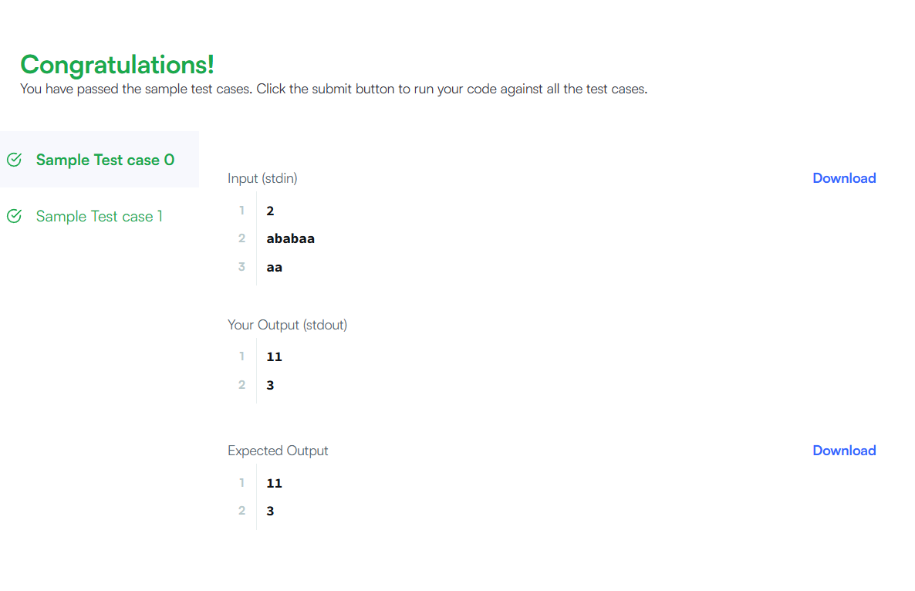

Task 2:
Program:
class Solution {
public boolean repeatedSubstringPattern(String s) {
String temp = s + s;
String modified = temp.substring(1, temp.length() - 1);
return modified.contains(s);

}
}
Output:

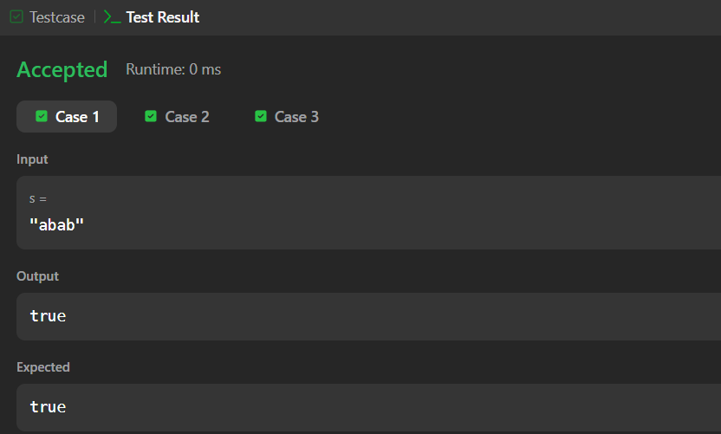

Task 3:
Program:
import java.io.*;
import java.math.*;
import java.security.*;
import java.text.*;
import java.util.*;
import java.util.concurrent.*;
import java.util.function.*;
import java.util.regex.*;
import java.util.stream.*;
import static java.util.stream.Collectors.joining;
import static java.util.stream.Collectors.toList;

class Result {
public static String twoStrings(String s1, String s2) {
// Write your code here
boolean[] chars = new boolean[26];
for (char c : s1.toCharArray()) {
chars[c - 'a'] = true;
}
for (char c : s2.toCharArray()) {
if (chars[c - 'a']) {
return "YES";
}
}
return "NO";

}

}

public class Solution {
public static void main(String[] args) throws IOException {
BufferedReader bufferedReader = new BufferedReader(new InputStreamReader(System.in));
BufferedWriter bufferedWriter = new BufferedWriter(new FileWriter(System.getenv("OUTPUT_PATH")));

int q = Integer.parseInt(bufferedReader.readLine().trim());

IntStream.range(0, q).forEach(qItr -> {
try {
String s1 = bufferedReader.readLine();

String s2 = bufferedReader.readLine();

String result = Result.twoStrings(s1, s2);

bufferedWriter.write(result);
bufferedWriter.newLine();
} catch (IOException ex) {
throw new RuntimeException(ex);
}
});

bufferedReader.close();
bufferedWriter.close();
}
}
Output:
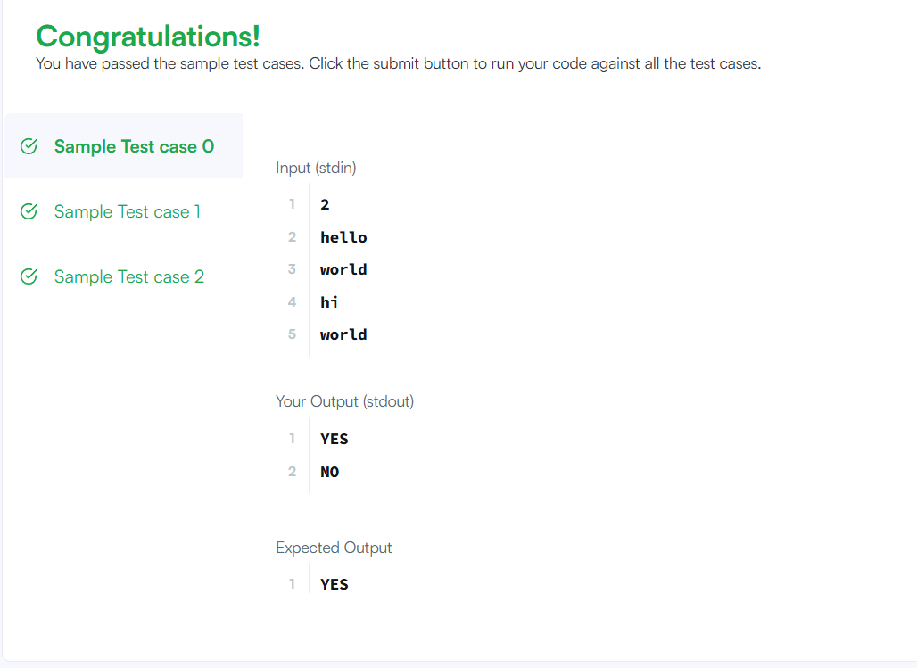

Task 4:

Program;
class Solution {
public boolean rotateString(String s, String goal) {

if (s.length() != goal.length()) {
return false;
}
String temp = s + s;
return temp.contains(goal);

}
}

Output:
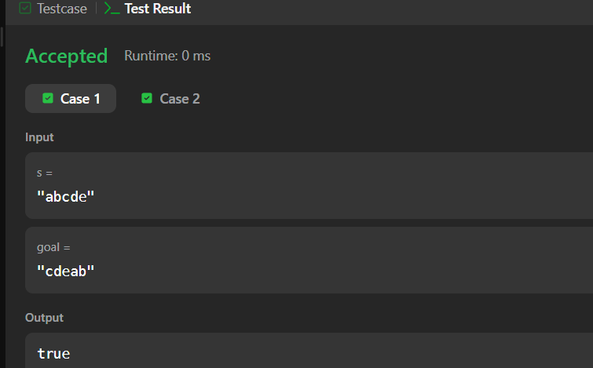
Task 5:
Program:
import java.io.*;
import java.math.*;
import java.security.*;
import java.text.*;
import java.util.*;
import java.util.concurrent.*;
import java.util.function.*;
import java.util.regex.*;
import java.util.stream.*;
import static java.util.stream.Collectors.joining;
import static java.util.stream.Collectors.toList;

class Result {

public static int marsExploration(String s) {
// Write your code here

int count = 0;

for (int i = 0; i < s.length(); i++) {
if (i % 3 == 0 && s.charAt(i) != 'S') count++;
if (i % 3 == 1 && s.charAt(i) != 'O') count++;
if (i % 3 == 2 && s.charAt(i) != 'S') count++;
}

return count;
}

public static void main(String[] args) {
Scanner sc = new Scanner(System.in);
String s = sc.next();
System.out.println(marsExploration(s));
sc.close();
}
}

public class Solution {
public static void main(String[] args) throws IOException {
BufferedReader bufferedReader = new BufferedReader(new InputStreamReader(System.in));
BufferedWriter bufferedWriter = new BufferedWriter(new FileWriter(System.getenv("OUTPUT_PATH")));

String s = bufferedReader.readLine();

int result = Result.marsExploration(s);

bufferedWriter.write(String.valueOf(result));
bufferedWriter.newLine();

bufferedReader.close();
bufferedWriter.close();
}
}
Output:
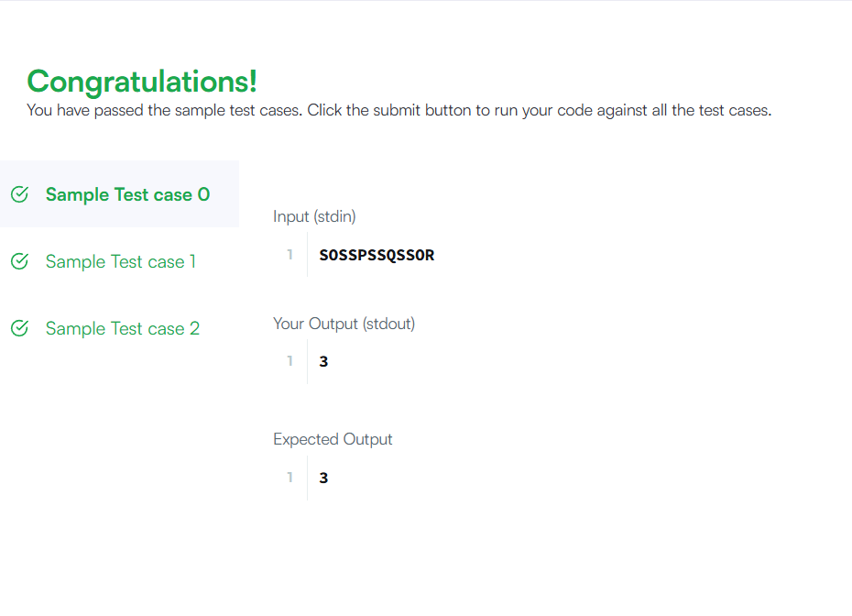

Task 6:
Program:
import java.util.*;

class Solution {
public List<Integer> findAnagrams(String s, String p) {
List<Integer> result = new ArrayList<>();
if (s.length() < p.length()) return result;

int[] pCount = new int[26];
int[] sCount = new int[26];

for (char c : p.toCharArray()) {
pCount[c - 'a']++;
}

for (int i = 0; i < s.length(); i++) {
sCount[s.charAt(i) - 'a']++;

if (i >= p.length()) {
sCount[s.charAt(i - p.length()) - 'a']--;
}

if (Arrays.equals(pCount, sCount)) {
result.add(i - p.length() + 1);
}
}

return result;
}
}
Output:
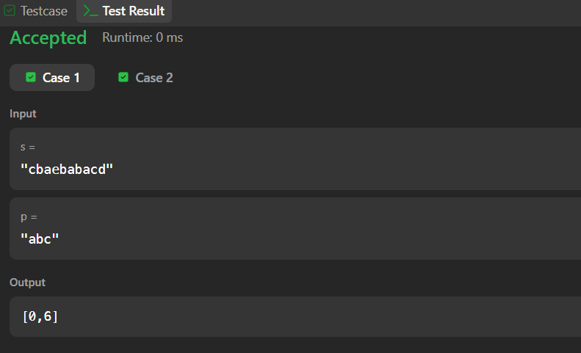

Task 7:
Program:
import java.io.*;
import java.math.*;
import java.security.*;
import java.text.*;
import java.util.*;
import java.util.concurrent.*;
import java.util.function.*;
import java.util.regex.*;
import java.util.stream.*;
import static java.util.stream.Collectors.joining;
import static java.util.stream.Collectors.toList;

class Result {

/*
* Complete the 'palindromeIndex' function below.
*
* The function is expected to return an INTEGER.
* The function accepts STRING s as parameter.
*/

public static int palindromeIndex(String s) {
// Write your code here
int left = 0;
int right = s.length() - 1;

while (left < right) {
if (s.charAt(left) == s.charAt(right)) {
left++;
right--;
} else {
if (isPalindrome(s, left + 1, right)) {
return left;
} else if (isPalindrome(s, left, right - 1)) {
return right;
} else {
return -1;
}
}
}
return -1;
}

public static boolean isPalindrome(String s, int left, int right) {
while (left < right) {
if (s.charAt(left) != s.charAt(right)) {
return false;
}
left++;
right--;
}
return true;
}

}

public class Solution {
public static void main(String[] args) throws IOException {
BufferedReader bufferedReader = new BufferedReader(new InputStreamReader(System.in));
BufferedWriter bufferedWriter = new BufferedWriter(new FileWriter(System.getenv("OUTPUT_PATH")));

int q = Integer.parseInt(bufferedReader.readLine().trim());

IntStream.range(0, q).forEach(qItr -> {
try {
String s = bufferedReader.readLine();

int result = Result.palindromeIndex(s);

bufferedWriter.write(String.valueOf(result));
bufferedWriter.newLine();
} catch (IOException ex) {
throw new RuntimeException(ex);
}
});

bufferedReader.close();
bufferedWriter.close();
}
}

Output:
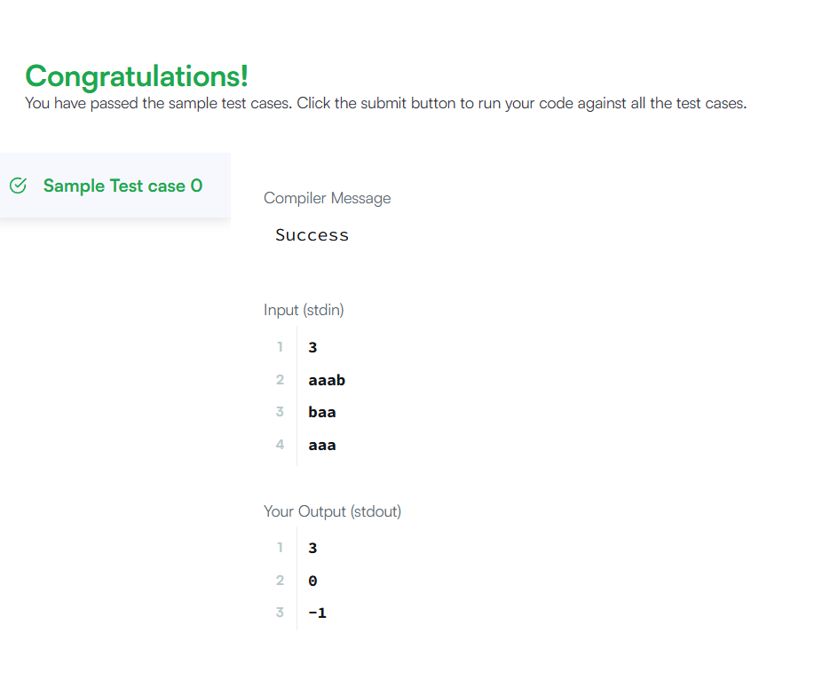

Task 8:
Program:

class Solution {
public int strStr(String haystack, String needle) {
int n = haystack.length();
int m = needle.length();

for (int i = 0; i <= n - m; i++) {
if (haystack.substring(i, i + m).equals(needle)) {
return i;
}
}
return -1;
}
}

Output:

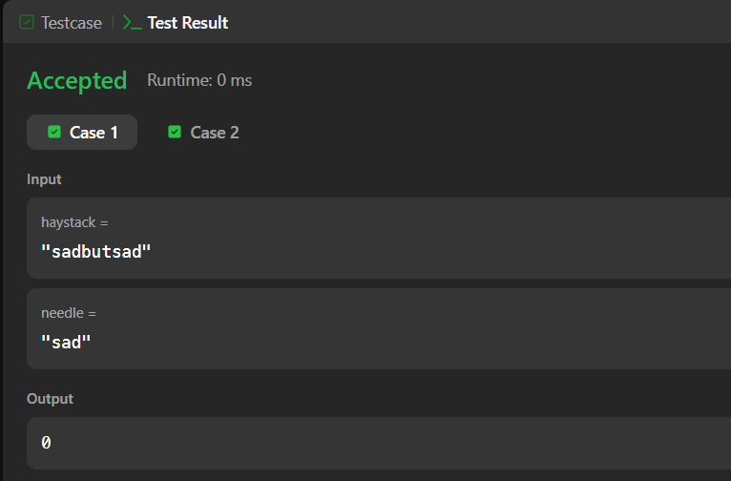

Task 9:
Program:

class Solution {
public String longestPalindrome(String s) {
if (s == null || s.length() < 1) return "";
int start = 0, end = 0;
for (int i = 0; i < s.length(); i++) {
int len1 = expand(s, i, i);
int len2 = expand(s, i, i + 1);
int len = Math.max(len1, len2);
if (len > end - start) {
start = i - (len - 1) / 2;
end = i + len / 2;
}
}
return s.substring(start, end + 1);
}

private int expand(String s, int left, int right) {
while (left >= 0 && right < s.length() && s.charAt(left) == s.charAt(right)) {
left--;
right++;
}
return right - left - 1;
}
}
Output :
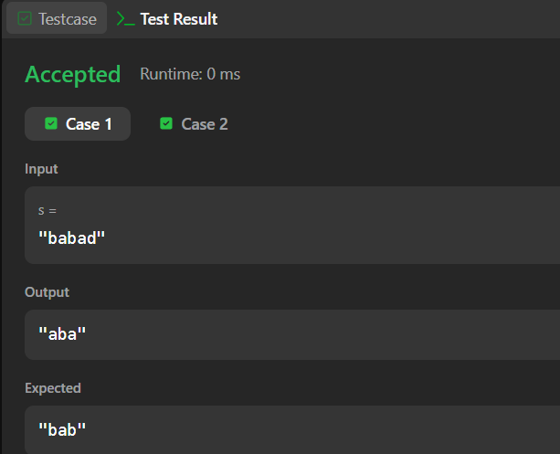

Task 10:
Program:
import java.io.*;
import java.math.*;
import java.security.*;
import java.text.*;
import java.util.*;
import java.util.concurrent.*;
import java.util.function.*;
import java.util.regex.*;
import java.util.stream.*;
import static java.util.stream.Collectors.joining;
import static java.util.stream.Collectors.toList;

class Result {

/*
* Complete the 'circularPalindromes' function below.
*
* The function is expected to return an INTEGER_ARRAY.
* The function accepts STRING s as parameter.
*/

public static List<Integer> circularPalindromes(String s) {
// Write your code here
List<Integer> res = new ArrayList<>();
String rotated = s;

for (int i = 0; i < s.length(); i++) {
res.add(longestPalindrome(rotated));
rotated = rotated.substring(1) + rotated.charAt(0);
}

return res;
}

public static int longestPalindrome(String s) {
int maxLen = 1;

for (int i = 0; i < s.length(); i++) {
int len1 = expand(s, i, i);
int len2 = expand(s, i, i + 1);
maxLen = Math.max(maxLen, Math.max(len1, len2));
}

return maxLen;
}

public static int expand(String s, int left, int right) {
while (left >= 0 && right < s.length() && s.charAt(left) == s.charAt(right)) {
left--;
right++;
}
return right - left - 1;
}

}

public class Solution {
public static void main(String[] args) throws IOException {
BufferedReader bufferedReader = new BufferedReader(new InputStreamReader(System.in));
BufferedWriter bufferedWriter = new BufferedWriter(new FileWriter(System.getenv("OUTPUT_PATH")));

int n = Integer.parseInt(bufferedReader.readLine().trim());

String s = bufferedReader.readLine();

List<Integer> result = Result.circularPalindromes(s);

bufferedWriter.write(
result.stream()
.map(Object::toString)
.collect(joining("\n"))
+ "\n"
);

bufferedReader.close();
bufferedWriter.close();
}
}

Output :

